CHAPTER 5: Chemical reactions

Worksheet 5.1

Chemical equations
Answers

Atom and mass conservation
1. Consider the following reaction between carbon dioxide and hydrogen.
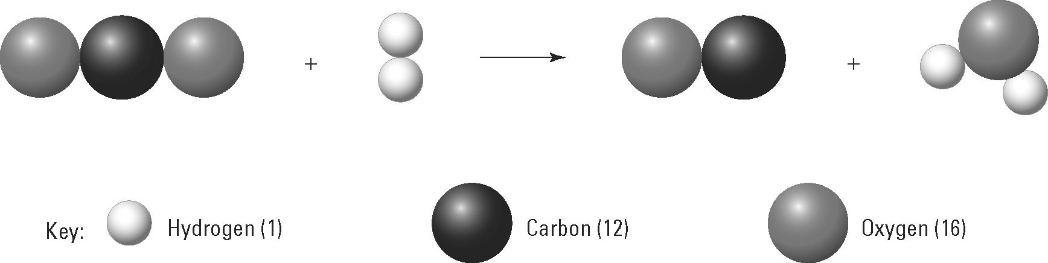
(a) Name the products of this reaction.
Carbon monoxide; water

(b) Show that the number of atoms of each element is conserved in the reaction.
Reactants: C = 1; O = 2; H = 2
Products: C = 1; O = 2; H = 2

(c) Use the atomic weight data provided in the key to show that the total mass of reactants equals the total mass of products.
Reactant mass = (12 + 16 + 16) + (1 + 1) = 46
Product mass = (12 + 16) + (1 + 1 + 16) = 46

Balancing an equation
2. The following diagram models a chemical reaction, but the equation is not balanced.
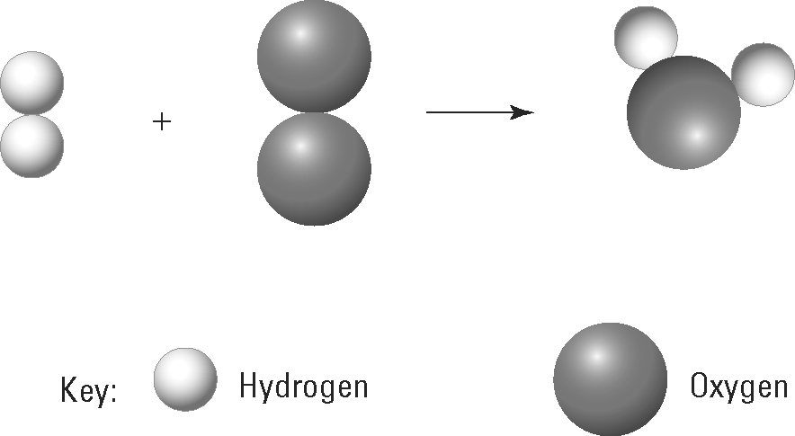
(a) Explain why this equation is not balanced.
The number of atoms of each element in the reactants (H = 2; O = 2) does not equal the number of atoms in the product (H = 2; O = 1).

(b) Draw in extra molecules in the diagram above to balance the equation being modelled.
